Report

TCP Client

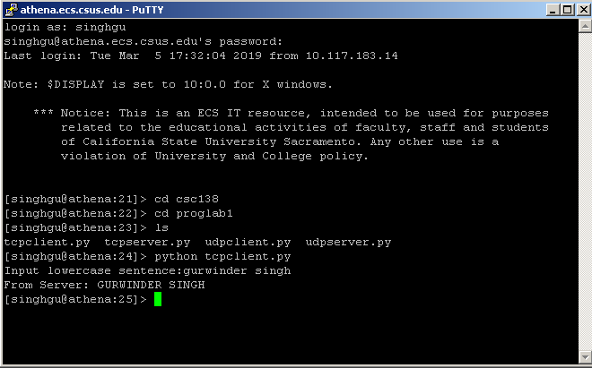

Source Code:

from socket import*

serverName = '127.0.0.1'

serverPort = 486753

clientSocket = socket(AF_INET, SOCK_STREAM)

clientSocket.connect((serverName,serverPort))

sentence = raw_input('Input lowercase sentence:')

clientSocket.send(sentence)

modifiedSentence = clientSocket.recv(1024)

print 'From Server:', modifiedSentence

clientSocket.close()

TCP Server

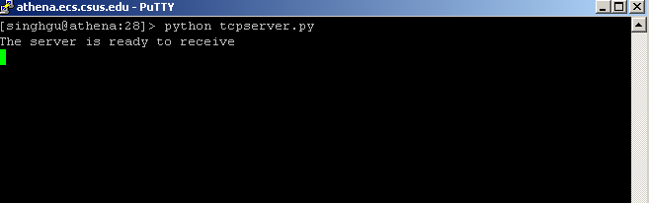

Source Code:

from socket import*

serverPort = 486753

serverName = '127.0.0.1'

serverSocket = socket(AF_INET,SOCK_STREAM)

serverSocket.bind((serverName,serverPort))

serverSocket.listen(1)

print 'The server is ready to receive'

while 1:

connectionSocket, addr = serverSocket.accept()

sentence = connectionSocket.recv(1024)

capitalizedSentence = sentence.upper()

connectionSocket.send(capitalizedSentence)

connectionSocket.close()

UDP Client

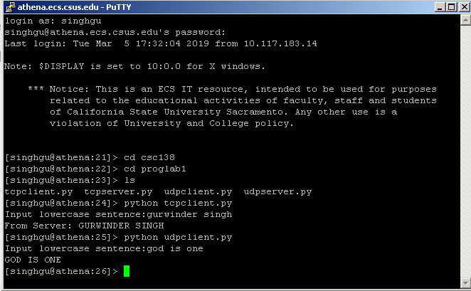

Source Code:

from socket import *

serverName = '127.0.0.1'

serverPort = 57283

clientSocket = socket(AF_INET, SOCK_DGRAM)

message = raw_input('Input lowercase sentence:')

clientSocket.sendto(message,(serverName, serverPort))

modifiedMessage, serverAddress = clientSocket.recvfrom(2048)

print modifiedMessage

clientSocket.close()

UDP Server

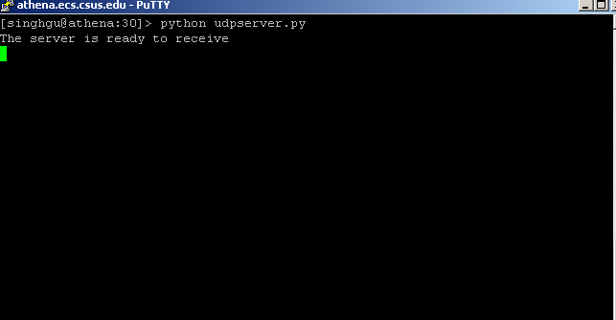

Source Code:

from socket import *

serverPort = 57283

serverSocket = socket(AF_INET, SOCK_DGRAM)

serverSocket.bind(('', serverPort))

print 'The server is ready to receive'

while 1:

message, clientAddress = serverSocket.recvfrom(2048)

modifiedMessage = message.upper()

serverSocket.sendto(modifiedMessage, clientAddress)

Analysis:

* TCP (Transmission control Protocol) is connection oriented and UDP ( User Datagram Protocol is connection less.
  + The way I think of TCP is like tunnel where data is transferred without being lost just like the way we would pass water between two containers by using pipe whereas UDP the data can be lost. We can think of it like people are transferring water by throwing it to another container. When receiver receives the water it’s going to splash and data (water) will be lost.
* In UDP client first create the datagram with server IP address and port # and send datagram through client socket. UDP server read the datagram and writes the reply to the client IP and port number and client read the datagram and close it.
* In TCP client first make the connection with server and the send the request and server reads the request. After that write the reply and client reads the reply and the close. In TCP server and client are not dependent on each other they are working separately and communicating with each other through the connection that they set up in first stage.